Legal Memorandum
Enforceability of Non-compete agreement - XYZ Corp. v. jane doe
Addilyn Goodno
2025
Contents
Question Presented 2
Brief Answer 2
2
Statement of Facts 2
Discussion and Analysis 4
Applicable Law (Hawaiʻi) 4
Application to the Doe Agreement 5
Conclusion 0
Recommendations 1
References 1

Question Presented
Is the non-compete clause signed by Jane Doe—prohibiting her from working for any competitor within Honolulu County for two years—enforceable under Hawaiʻi law?

Brief Answer
Partially, but not as written. Under Hawaiʻi law, employee non-competes are enforceable only if they protect a legitimate business interest and are reasonable in duration, geography, and scope; Hawaiʻi courts also consider undue hardship on the employee and injury to the public. A two-year duration and Honolulu County-only geography generally fall within accepted bounds. However, a blanket ban on working for “any competitor” is likely overbroad. The clause would likely be narrowed or partially enforced to protect XYZ’s confidential information and customer goodwill without unduly restricting Doe’s ability to work.


Statement of Facts
XYZ Corporation (“XYZ”) hired Jane Doe in 2020 as a marketing manager in Honolulu. On hire, Doe signed an employment agreement containing a non-compete clause that prohibits her, for two years after separation, from “working for any competitor within Honolulu County in any capacity.” In June 2024, Doe resigned and joined ABC Consulting, which competes with XYZ in regional marketing services. XYZ filed suit in Hawaiʻi circuit court to enforce the non-compete and obtain injunctive relief barring Doe from continued employment with ABC.
The relevant portion of Doe’s employment contract is reproduced below (Figure 1).
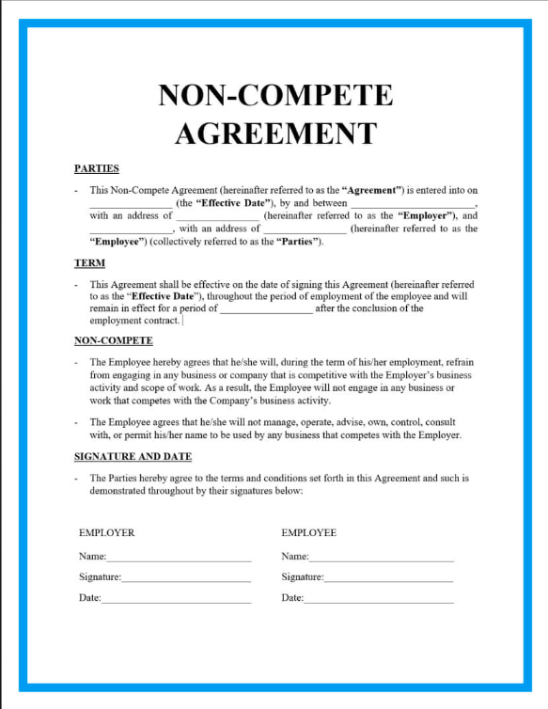
Party | Business | Role | Access to Confidential Information | Post-Employment Role
Plaintiff (XYZ Corporation) | Honolulu-based marketing firm | Employer | Client lists, pricing models, campaign strategies | Seeking to enforce non-compete agreement
Defendant (Jane Doe) | Now employed at ABC Consulting, a competing marketing firm in Honolulu | Former marketing manager at XYZ Corporation (2020-2024) | Had access to confidential client data and strategies | Marketing manager at ABC Consulting

Discussion and Analysis

Applicable Law (Hawaiʻi)
- Reasonableness & Legitimate Purpose. Hawaiʻi enforces post-employment restraints only if they are no greater than necessary to protect the employer’s legitimate interests (trade secrets, confidential information, customer relationships); do not impose undue hardship on the employee; and are not injurious to the public. This three-part test traces to Technicolor, Inc. v. Traeger, where the Hawaiʻi Supreme Court emphasized the balance between protection and restraint.
- Modern Guidance. In Prudential Locations, LLC v. Gagnon (2022), the Hawaiʻi Supreme Court declined to enforce a real-estate non-compete/non-solicit because the employer failed to show a legitimate purpose beyond stifling competition and because the restrictions were not sufficiently tied to protectable interests. The Court clarified that protecting against ordinary competition is not enough; employers must show the restraint targets confidential information or goodwill.
- Statutory Overlay — HRS § 480-4. Hawaiʻi’s antitrust statute prohibits contracts in restraint of trade and, since Act 158 (2015), makes employee non-compete and non-solicit clauses void in the “technology business sector.” Outside the tech carve-out, non-competes remain subject to the reasonableness test above.

Application to the Doe Agreement
A. Duration (Two Years)
Hawaiʻi decisions and practice materials often view 1–2 years as within a reasonable range where the employer shows protectable interests. Here, two years aligns with typical enforcement brackets—particularly for employees with access to customer relationships and strategy. On balance, duration favors enforceability.
B. Geographic Scope (Honolulu County)
Tying the restraint to Honolulu County matches the locus of XYZ’s operations and target market. Courts prefer geography drawn to where the employer actually competes. A county-limited scope is thus narrowly tailored and likely reasonable.
C. Scope of Activity (“Any Competitor” / “Any Capacity”)
This is the weak point. A ban on working for “any competitor in any capacity” can prevent Doe from taking non-overlapping roles (e.g., back-office or unrelated functions), sweeping beyond what is necessary to protect XYZ’s interests. Under Prudential, merely avoiding competition is not a legitimate purpose; the restraint must target confidential information or goodwill at risk. The clause, as drafted, likely overreaches and should be narrowed to roles substantially similar to Doe’s former duties or that risk use of specific confidential assets.
D. Undue Hardship / Public Interest
Preventing Doe from working anywhere a competitor operates within the county for two years may impose significant hardship in a small island labor market. Hawaiʻi courts weigh hardship and public interest—e.g., worker mobility—against employer benefit. Legislative findings supporting Act 158 recognized broader harms from over-restrictive covenants in Hawaiʻi’s economy, underscoring caution with expansive restraints.
E. Partial Enforcement (“Blue Pencil” / Modification)
Hawaiʻi courts may partially enforce or modify overbroad covenants to render them reasonable, depending on the language and severability. Practically, courts can strike overbroad phrases (e.g., “in any capacity”) and enforce a narrower restraint focused on roles or client segments tied to protectable interests. Expect the court to narrow, rather than void entirely, if the agreement shows a legitimate purpose and reasonable time/area.

Employer (XYZ’s Arguments):
XYZ argues that Doe’s access to confidential client lists, pricing strategies, and campaign materials creates a substantial risk of unfair competition. Allowing her to move directly into a role with a competitor could enable the misuse of proprietary information, which courts recognize as a legitimate business interest worthy of protection.
XYZ also maintains that the restrictions in the agreement are reasonable in both duration and geography. Two years is a length that Hawaiʻi courts often uphold, and limiting the covenant to Honolulu County ensures that the scope is tied to XYZ’s actual market rather than being overbroad. Together, these points strengthen XYZ’s claim that enforcement is justified.
Employee (Doe’s Arguments):
Doe responds that the non-compete agreement is written far too broadly. By prohibiting her from working for “any competitor in any capacity,” the clause sweeps in jobs that pose no real threat to XYZ, such as administrative or back-office work. Hawaiʻi courts are unlikely to enforce such vague and expansive terms because they extend beyond protecting legitimate interests.
She further argues that the agreement imposes undue hardship in Hawaiʻi’s limited labor market. Preventing her from working in nearly all marketing positions for two years restricts her livelihood and runs counter to public policy favoring employee mobility. Doe contends that these factors weigh strongly against enforcement.

Recap of Employer’s Position (XYZ)

Recap of Employee’s Position (Doe)

Conclusion
Under Hawaiʻi law, the two-year duration and Honolulu County geography of Doe’s non-compete lean reasonable. The “any competitor / any capacity” wording likely exceeds what is necessary to protect XYZ’s legitimate interests and therefore should be narrowed. A court is likely to partially enforce the restraint by limiting it to roles that risk misuse of confidential information or customer goodwill, or by substituting a targeted non-solicitation. On balance, partial enforcement—not wholesale invalidation—is the most probable outcome here.

Recommendations
Recommended Action (Litigate, Settle, etc):
(Client-Facing Next Steps)
Propose a Narrowed Stipulated Injunction: Limit the restriction to marketing/BD roles serving XYZ’s existing customer segments and lines of business for the remaining 18 months.
Strengthen Confidentiality Protections: Obtain an order requiring deletion/return of client lists, pricing models, and strategy decks; require periodic certifications.
Customer Non-Solicit Only: If the court balks at a full non-compete, request a customer non-solicitation limited to listed key accounts for 12–18 months.
Internal Hygiene: Audit access logs, narrow confidential-info access, and implement exit interviews/reminders to reinforce trade secret policies going forward.

References
McAdams, J. M. (2019). Non-Compete Agreements: A Review of the Literature. SSRN, 24.
Natarajan Balasubramanian, J. W. (2022). Locked In? The Enforceability of Covenants Not to Compete and the Careers of High-Tech Workers. Journal of Human Resources, 57.

The FTC adopted a nationwide non-compete rule in 2024; however, its future effect is uncertain due to ongoing legal challenges.

